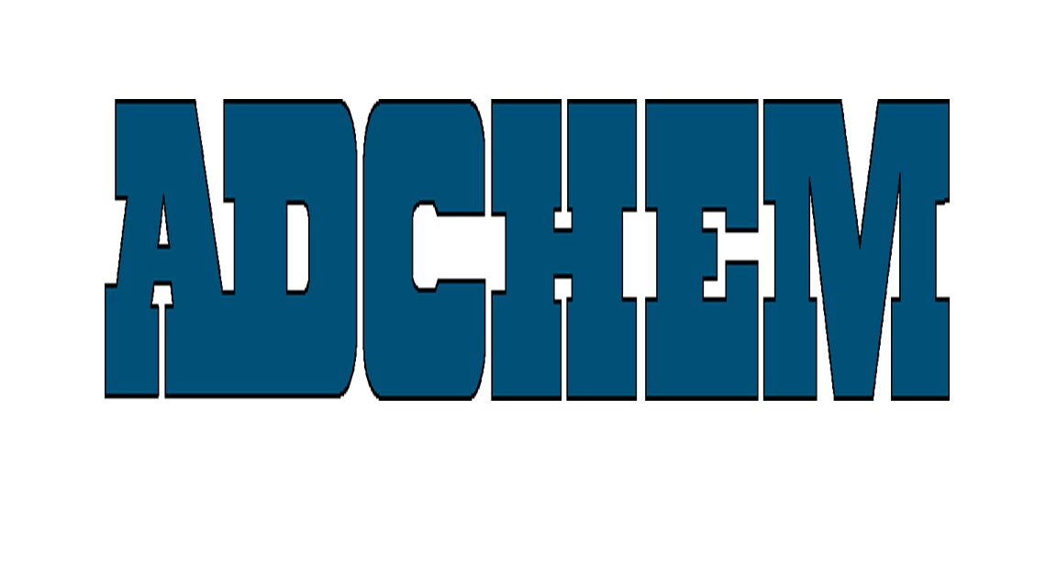
the adhesive tape engineersTM

For Immediate Release

Adchem Announces Adhesive Tapes for Rubber and Elastomeric Materials from American Biltrite

Adchem Corporation, a major supplier of adhesive tapes for the automotive and industrial markets, has completed a bonding study involving numerous rubber and elastomeric materials from American Biltrite. The study of nine adhesive tapes bonded to twenty-six grades of rubber products of different densities and durometers includes Adchem’s acrylic and rubber-based doubled-coated and transfer tapes as well as the new 6943 transfer tape engineered for Low VOC bonding. This information is available on Adchem’s web site shown below.

Adchem’s double-coated, single-coated and unsupported adhesive tape systems coupled with its advanced engineering capabilities enables Adchem to develop high performance adhesive tapes for the most demanding applications.

About Adchem Corporation
Adchem, an ISO 9001 certified and A2LA -accredited company, manufactures pressure-sensitive adhesive tape systems, including double-coated papers, films, tissues, foams and fabrics; transfer tapes; one-side coated products and other custom-coated specialty products. Our 100% solids adhesives, solvent and water based acrylics and rubber adhesives are used in a variety of industries, including automotive, construction, electronics, graphic arts, medical, and general industrial tape applications.

About American Biltrite
American Biltrite manufactures one of the widest selections of performance sheet rubber products in the industry. With an outstanding range of polymers, on-site mixing, state-of-the-art curing and fully equipped testing facilities, we have the expertise and the commitment to provide the exact solution for our customer’s applications. With ISO 9001 since 1996 and ISO 14001 since 2011, today American Biltrite continues to strive to improve its processes and its products.

For additional information and samples, please contact Chris Pufahl at Adchem Corporation, 1852 Old Country Road, Riverhead, NY 11901 Phone: (631) 727-6000 Fax: (631) 727-6010 or our website at www.adchem.com.

